

TEMPLATE SLEEP AND REST RISK ASSESSMENT.
From 1 October 2023, the approved provider, nominated supervisor and family day care (FDC) educator must take reasonable steps to ensure that the needs for sleep and rest of children being educated and cared for by the service are met, having regard to the ages, development stages and individual needs of the children (Education and Care Services National Regulations, regulation 84A). Approved providers must also ensure policies and procedures are in place for managing sleep and rest for children (regulation 168) and take reasonable steps to ensure those policies and procedures are followed (regulation 170). To ensure the safety of children during sleep and rest, from 1 October 2023, the approved provider must conduct a sleep and rest risk assessment at least once every 12 months, and as soon as practicable after becoming aware of any circumstance that may affect the safety, health and wellbeing of children during sleep and rest. The approved provider must make any necessary updates to the sleep and rest policies and procedures as soon as practicable after conducting the sleep and rest risk assessment and keep a record of each sleep and rest risk assessment conducted. This sleep and rest risk assessment template is designed to assist approved providers and services in conducting sleep and rest risk assessments. This template is a starting point and should be adapted to meet the individual needs of your service or FDC residence/venue in line with regulations 84A, 84B and 84C. It is a requirement for services and FDC residences or FDC venues to complete a sleep and rest risk assessment at least once every 12 months, and as soon as practicable after becoming aware of any circumstance that may affect the safety, health and wellbeing of children during sleep and rest. This document is intended to be an
evolving and regularly updated document, to be amended as circumstances change and new hazards arise.
Service Name: Woodlands ELC
Date of SLEEP AND REST RISK ASSESSMENT: 24th of September Review date of SLEEP AND REST RISK ASSESSMENT: March 2025. v
Provide details in the risk assessment table below. A sleep and rest risk assessment.
□ Medication, health plans and risk assessments for individual children- On airtable and in the room medical bags

Use the table below to identify and assess risks to the safety, health or wellbeing of children attending the excursion, and specify how these risks will be managed and minimised (regulation 101(1)). This must include any risks associated with water-based activities.
Activity | Hazard identified | Risk assessment (use matrix) | Elimination/control measures | Who | When
Supervision and monitoring  during sleep and rest periods. | Beds are not to be located in front of sinks or doorways. | Moderate | Always place the baby on their back. | ALL educators in the room. | Through all sleep and rest periods.
 | Children may turn and injure themselves while sleeping. | Low | An educator is at all times needing to be in eye sight of the sleep room, supervising inside the sleep and rest rooms. | ALL educators in the room. | Through all sleep and rest periods.
 | Children may
 | accidentally cover their faces with blankets. | Moderate | Door is to stay open and an educator is at all times needing to be in eye sight of the sleep room, supervising inside the sleep and rest rooms. . | ALL educators in the room | Through all sleep and rest periods.
The location of the sleep and rest areas | -Sleep checks not being Completed.  -Poor supervision may occur when the sleep area is not in the visible or in the correct location of the room.  -If beds are close to sinks, doors or food  areas, it is not safe | Low  Low  Low Moderate | Room leaders are to ensure all staff in their room are aware of and have a clear understanding on where to locate them. Sleep checks are to be done at least every 5 minutes, even though there are Educators in the room supervising, they need to be frequent and of a high standard, as per your service’s policy and procedures. In all cases, safe | ALL educators in the room and the leadership team to ensure the room is okay.  ALL educators in the room and the | Through all sleep and rest periods and a reflection after sleep routines.  Through all sleep and rest

 | and unhygienic. |  | sleep practices and regular | leadership team to | periods and a
 |  |  | physical checks must continue to | ensure the room is | reflection after
 | - Educators are needed to |  | be implemented, this information | okay. | sleep routines.
 | supervise in the sleep/rest |  | is to be updated on
 | rooms. | Moderate | Xplor/Playground for families to
 |  |  | see.
 |  |  | https://www.acecqa.gov.au/resou
 | Rooms to have an |  | rces/supporting-materials/infosh
 | understanding of the |  | eet/safe-sleep-and-rest-practices
 | supervision requirements. |  |  | Room leader and  Leadership to support. | Through all sleep and rest  periods and a
 |  |  | Door is to stay open and an educator is at all times needing to be in eye sight of the sleep room, supervising inside the sleep and rest rooms. Ensure  staff clearly communicate the |  | reflection after sleep routines.
 |  |  | supervision requirements.
 |  |  | The team will regularly reflect on
 |  |  | the layout of the sleep/rest room
 |  |  | or area.
How the sleep | -Educators are not | Low | Leadership teams are always | Leadership team | Leadership
and rest | educated with the correct |  | updating and providing | and educators. | team each
practices are | procedures that uphold safety |  | resources to educators to | Educators are to ask | month in the a
consistent with | for children sleeping and |  | ensure they are building on their | when they require | staff meeting
any current health guidelines. | educators not following correct procedures. |  | knowledge.  Educators are aware of the regulations and guidelines via ACECQA and red nose.  https://rednose.org.au/download s/PhysicalChecks.pdf | further knowledge or if they don't understand something. Educators to be accountable for their responsibilities and needs. | provides a section for sleep procedures.

 | 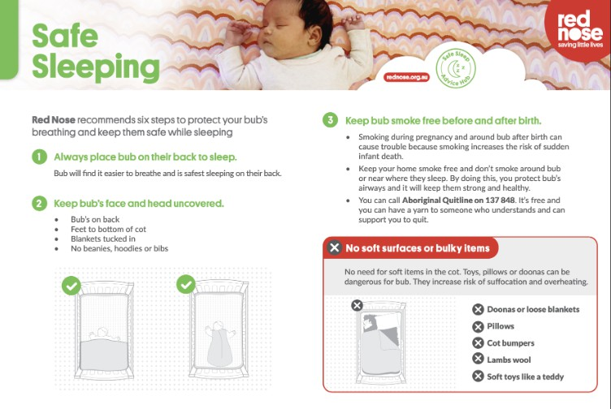  -Children are left in bouncers to sleep. | Low | https://www.acecqa.gov.au/r sources/supporting-materials/inf osheet/safe-sleep-and-rest-pract ices#Best  Educators are transferring the baby directly to the cot if they fall asleep in the bouncer. | All staff are to be responsible to ensure there are no children sleeping in the bouncer. | When children are resting and through sleep time.
The sleep and rest needs of children at the service. | Educators not knowing the child’s rest/sleep routines.  Families forcing educators to keep children awake, or sleeping for a certain time.  -Educators are to educate themselves and families around th new Child Safe  standards and the importance of sleep. | Low  Low  Low Moderate | Leadership team to ensure through  The orientation is correct.  -children who do not wish to sleep are provided with opportunities for play, while those children who do wish to sleep are able to do so, without being disrupted.  If a child requests a rest, or if they are clear signs of tiredness,  regardless of the time of day, there should be a comfortable, safe area available for them to sleep or rest.  Information is gathered and clearly written onto the  child’s Xplor profile. | All educator educators in the room to know where to find the information and for the Leadership team to gather the correct information for the  educators.  Families need to communicate any Updates.  Leadership team to gather the correct information for  the educators.  https://www.acecqa. gov.au/resources/sup porting-materials/info sheet/safe-sleep-and | When children start and when children's  routines change, Update slightly.  Leadership team each month in the a staff meeting provides a  section for sleep procedures.

-r e st-practices

Risk MatrixRisk Matrix.
Consequences. | Likelihood.
Consequences. |  | Rare | Unlikely Possible | Likely | Almost Certain
Consequences. | Major | Moderate | High High | Critical | Critical
Consequences. | Significant | Moderate | Moderate High | High | Critical
Consequences. | Moderate | Low | Moderate Moderate | High | High
Consequences. | Minor | Very low | Low Moderate | Moderate | Moderate
Consequences. | Insignificant | Very low | Very low Low | Moderate | Moderate

Plan and Review
Plan prepared by: Full name: Angelica Furnari Signature:  Role/Position: Head of Education. | Date: 24/09/2024
Prepared in consultation with: Full name: Signature:
Role/Position:

